Velazquez, Adrian
03/02/2024

Title: Walmart Weekly Sales Predictive Model
Introduction
In the dynamic landscape of retail, efficient inventory management stands as a cornerstone for success. For Walmart, a retail giant operating across numerous locations, accurately predicting weekly sales is not just a goal but a strategic necessity. This project delves into the intricacies of building a predictive model for Walmart's sales using historical data spanning from 2010 to 2012. By analyzing internal and external factors influencing sales, we aim to provide actionable insights focused on predicting weekly sales to optimize Walmart's supply chain, staffing, and marketing strategies.
Justification:
Accurate sales prediction is paramount for Walmart, as it directly impacts various aspects of its operations and strategic decision-making. Here are key points justifying the significance of solving this problem:
  - Optimized Inventory Management: Precise sales forecasts enable Walmart to maintain optimal inventory levels across its stores. By predicting demand accurately, the company can avoid stockouts or overstock situations, thus minimizing inventory holding costs and maximizing profitability.
  - Efficient Staffing: Sales predictions help Walmart in workforce planning and scheduling. By aligning staffing levels with anticipated sales volumes, the company can ensure adequate customer service while controlling labor costs. This leads to enhanced operational efficiency and improved customer satisfaction.
  - Strategic Marketing: Understanding sales patterns and consumer behavior allows Walmart to tailor its marketing strategies effectively. By identifying peak sales periods, seasonal trends, and customer preferences, the company can allocate marketing resources efficiently to drive sales and enhance brand loyalty.
  - Cost Savings: By leveraging predictive analytics to optimize inventory, staffing, and marketing efforts, Walmart can realize significant cost savings. Reduced carrying costs, minimized labor expenses, and targeted marketing campaigns contribute to improved cost efficiency and higher profitability.

Pitch to Stakeholders:
When presenting the problem to stakeholders to gain their support, it's essential to highlight the potential benefits and return on investment (ROI) of developing a predictive sales model for Walmart. Here's an outline of how the problem can be pitched effectively:
  - Introduction to the Problem: Start by providing an overview of the challenges faced by Walmart in managing its sales operations efficiently. Emphasize the critical role of accurate sales prediction in driving business success and maintaining a competitive edge in the retail industry.
  - Significance and Relevance: Clearly articulate the significance of solving the problem by highlighting the direct impact on key areas such as inventory management, staffing, and marketing strategies. Illustrate how improved sales forecasting can lead to cost savings, operational efficiency, and revenue growth for Walmart.
  - Demonstration of Need: Present compelling data and examples showcasing the current limitations in sales forecasting methods and the potential risks associated with inaccurate predictions. Use real-world scenarios and case studies to illustrate the tangible benefits of implementing a robust predictive model.
  - Value Proposition: Outline the value proposition for stakeholders, emphasizing the potential ROI and long-term benefits of investing in predictive analytics. Discuss how the proposed solution aligns with Walmart's strategic objectives and corporate goals, positioning it as a strategic initiative with substantial business impact.
  - Engagement and Collaboration: Encourage stakeholder engagement by soliciting feedback, addressing concerns, and fostering a collaborative approach towards problem-solving. Emphasize the importance of cross-functional collaboration and knowledge sharing to ensure the success of the project.
  - Call to Action: Conclude the pitch with a clear call to action, urging stakeholders to support the initiative and allocate resources for its implementation. Highlight the potential competitive advantage and market differentiation that Walmart can achieve through advanced sales forecasting capabilities.

Data Acquisition
- Source of Data:
For this project, the primary source of data was the Kaggle platform, specifically datasets related to Walmart sales data. The datasets were obtained from Kaggle's publicly available repositories, which host a diverse collection of datasets contributed by users worldwide. The specific datasets used for this project were selected based on their relevance to Walmart's sales operations and their suitability for predictive modeling.
Download and Preprocessing: Once the datasets were selected, I downloaded them from Kaggle in a suitable format CSV. Before proceeding with the analysis and data preprocessing tasks such as cleaning, merging, and transforming; since I currently work at Walmart; I asked my manager to make this final project a chance to meet with her and simulate a Data Mining Project. She crafted a dataset from the ones I provided. She made it unique so I could have a different experience than that of other people who worked with the original datasets. This simulation not only provided a realistic representation of the data mining project environment but also offered an invaluable opportunity for me to apply advanced analytical techniques in a controlled setting.

Milestones Summary
Milestone 1: Exploratory Data Analysis (EDA)
In the initial phase of the project, several crucial steps were undertaken to set up the environment and conduct exploratory data analysis (EDA). These steps included setting the working directory, importing necessary libraries, loading the dataset, and performing graphical analysis to gain insights into the Walmart sales data.
  - Initial Settings: The working directory was set to the project folder, and essential libraries including Pandas, NumPy, Seaborn, Matplotlib, and Scikit-learn were imported. The dataset was loaded from the provided CSV file ('walmart_sales_dataset.csv') into a Pandas DataFrame named 'walmart_df'. This DataFrame consists of 4320 rows and 13 columns, containing information such as store number, date, temperature, fuel price, markdowns, CPI, unemployment rate, weekly sales, and a flag indicating if it's a holiday week.
  - Graphical Analysis: Four key graphs were generated to explore different aspects of the data:
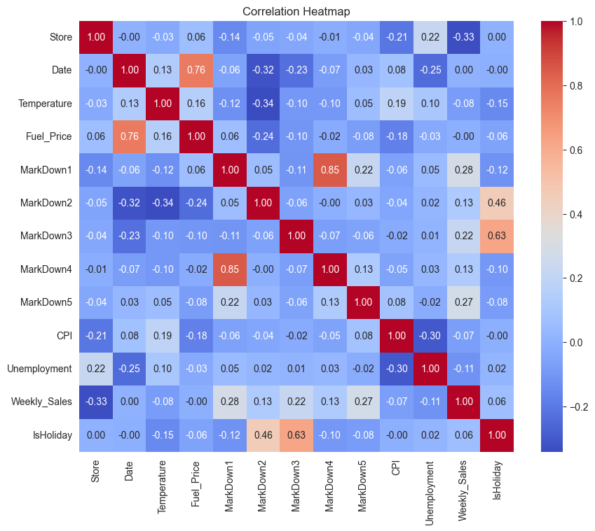
  - Graph #1: Correlation Heatmap A heatmap was created to visualize the correlations between various variables and weekly sales. The analysis revealed weak correlations, suggesting that changes in temperature, fuel price, CPI, and unemployment rate are not strongly tied to proportional changes in weekly sales. However, it's important to note that weak linear correlations do not necessarily imply the absence of relationships, and further exploration is warranted.

  - Graph #2: Holiday vs. Non-Holiday Sales Comparison A bar chart compared the average weekly sales during holiday and non-holiday weeks. The visualization indicated higher sales on holiday weeks, emphasizing the importance of predicting sales spikes during holiday periods to optimize business strategies.

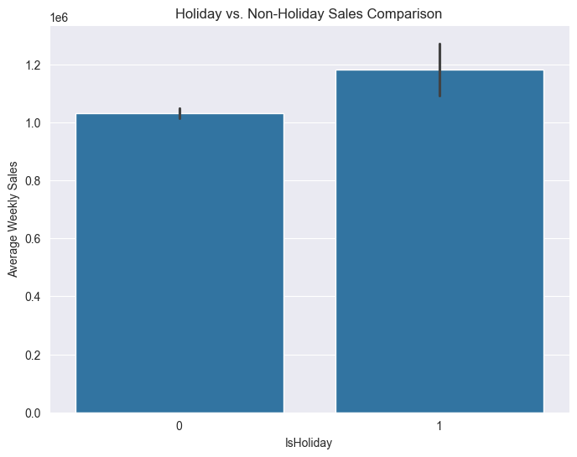

  - Graph #3: Time Series Plot of Weekly Sales A time series plot illustrated weekly sales trends over time, revealing spikes in sales during certain months. This observation suggests the presence of seasonality in sales data and underscores the opportunity to analyze and predict these fluctuations for strategic planning.
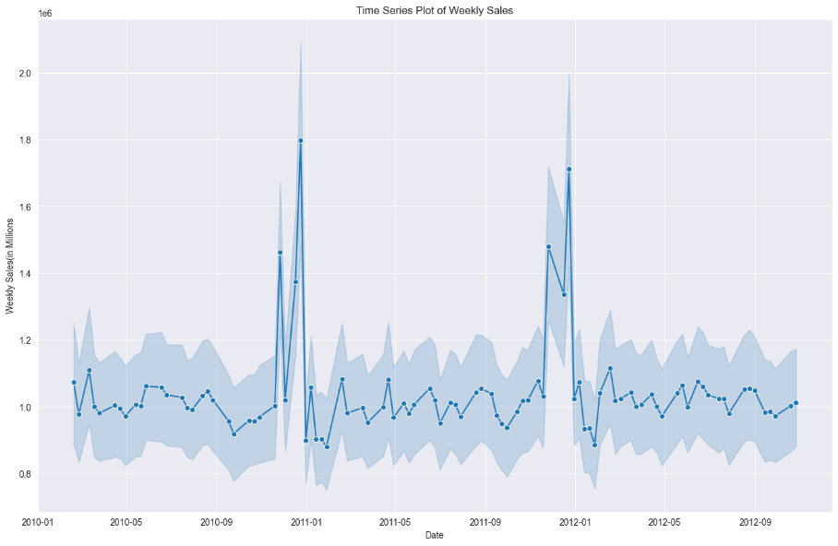

  - Graph #4: Distribution of Temperature and Sales A scatter plot explored the relationship between temperature and weekly sales, with holidays highlighted. While the graph suggested an inverse correlation between temperature and sales, caution was advised in interpretation due to potential confounding factors such as geographical diversity in store locations and regional climates.

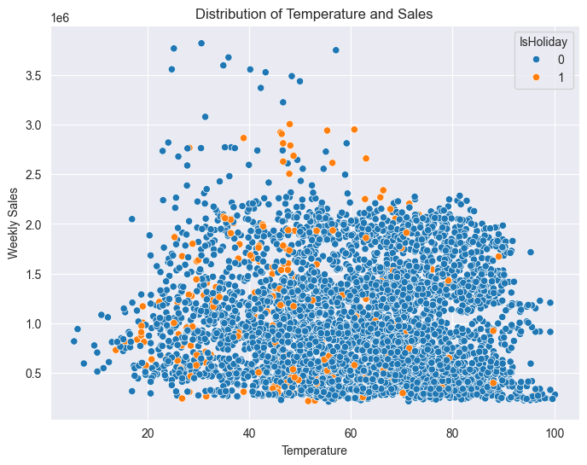

Milestone 2: Data Preparation
In this milestone, the data was prepared for modeling by performing various data cleaning, preprocessing, and feature engineering techniques. Here are the steps taken:
  - Data Types Handling:
  - Converted the 'Store' column to integer type.
  - Converted the 'Date' column to datetime format.
  - Renamed the 'IsHoliday' column to 'Holiday_Flag' for clarity.
  - Drop Duplicates:
  - Checked for and dropped any duplicate rows from the dataset.
  - Missing Values Handling:
  - Checked for NaN values in each column.
  - Replaced missing values in 'MarkDown' columns with 0 as these values are monetary and can be assumed to be 0 when not provided.
  - Negative Values Handling:
  - Identified numeric columns and counted negative values.
  - As the negative values were minimal (less than 1% of the dataset) and their meaning was unclear, rows with negative values for 'MarkDown2' and 'MarkDown3' were discarded.
  - Feature Engineering:
    - Created a new column 'Markdown' by summing the values of 'MarkDown1' through 'MarkDown5'.
    - Extracted week numbers from the 'Date' column and created a new column 'Week'.
    - Generated dummy variables for 'Holiday_Flag' and 'Week' columns to convert categorical variables into numerical representations.
  - Created Different Data Frames by Store:
  - Grouped the data by the 'Store' column.
  - Created a separate DataFrame for each store and stored them in a dictionary for further analysis.
  - These steps ensure that the data is clean, properly formatted, and ready for modeling. Further adjustments and analysis will be performed in subsequent milestones.

Milestone 3: Model Building and Evaluation

In this milestone, a Random Forest Regressor model was explored for predicting Walmart's weekly sales. In the first run around, many mistakes were made and the dataset wasn’t prepared properly. This lead awful results for the Random Forest Model Performance.

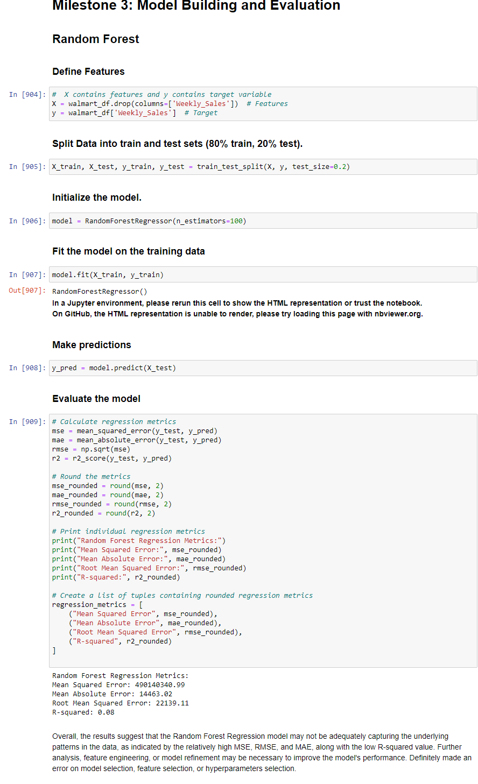
Milestone 4: Final submission

After carefully reconstructing the data and making necessary transformations I basically re did Milestone 3:
- Milestone 3: Model Building and Evaluation
We explored multiple models to predict weekly sales at Walmart stores and evaluated their performance using various metrics. Here's a summary of the models explored and the evaluation metrics used:
Models Explored:
- Random Forest Regression: We trained Random Forest regression models for each store individually. Random Forest is an ensemble learning method that builds multiple decision trees and combines their predictions to improve accuracy and robustness.
- Gradient Boosting Regressor: Another ensemble learning method, Gradient Boosting Regressor, was also employed. It builds trees sequentially, with each tree correcting the errors of the previous one, potentially leading to improved accuracy.
- Time Series Analysis with ARIMA: For one store (Store 4), we applied time series analysis using the AutoRegressive Integrated Moving Average (ARIMA) model. ARIMA is a widely used approach for analyzing and forecasting time series data.
Evaluation Metrics:
- Mean Absolute Error (MAE): Measures the average absolute errors between predicted and actual values. Lower MAE indicates better accuracy.
- Mean Squared Error (MSE): Measures the average of the squares of the errors. Lower MSE suggests better accuracy.
- R-squared (R²): Indicates the proportion of the variance in the dependent variable that is predictable from the independent variables. Higher R-squared values denote better model fit.
- Root Mean Squared Error (RMSE): The square root of the MSE, providing an interpretable measure of the average magnitude of errors.

Results of Model Training and Evaluation:
- Random Forest Regression: The Random Forest models showed relatively low average MAE and MSE across all stores, indicating reasonably accurate predictions. The average R-squared value suggested that the models explain a significant portion of the variability in the data.
- Gradient Boosting Regressor: The Gradient Boosting Regressor models exhibited lower MSE, MAE, and RMSE compared to Random Forest, but a lower R-squared value, indicating they explained less variance in the data.
- ARIMA Time Series Analysis: The ARIMA model applied to Store 4 showed potential shortcomings based on AIC, BIC, parameter significance, and diagnostic tests. It may not be suitable for forecasting weekly sales due to issues with model fit and diagnostic tests.

Conclusion
Analysis and Model Insights:
  - Random Forest Reigns: Our analysis revealed that Random Forest regression consistently outperformed other models in predicting weekly sales across various Walmart stores. It demonstrated lower mean absolute error (MAE), mean squared error (MSE), and higher R-squared values, indicating superior accuracy and better fit to the data compared to Gradient Boosting Regressor and ARIMA.
- Model Deployment Readiness:
  - The Random Forest regression model is ready for deployment with considerations. Before deployment, thorough testing and validation on new data are necessary to ensure its robustness and reliability in real-world scenarios. Additionally, model performance monitoring and regular updates may be needed to adapt to changing store dynamics and external factors.
- Recommendations:
  - Utilize Random Forest for Sales Prediction: We recommend deploying the Random Forest regression model for predicting weekly sales at Walmart stores. This model has demonstrated strong performance in accuracy and generalizability, making it a valuable tool for sales forecasting.
  - Store-Specific Modeling: Consider implementing store-specific modeling strategies to account for the variability observed in model performance across different stores. Tailoring models to individual store characteristics could further enhance predictive accuracy.
- Challenges and Opportunities:
  - Data Quality and Feature Engineering: Addressing challenges related to data quality and feature engineering could improve model performance. Exploring additional features or refining existing ones may uncover valuable insights and enhance predictive capabilities.
  - External Factors Integration: Incorporating external factors such as economic indicators, seasonality, and promotions could enrich the modeling process and provide more accurate predictions. This presents an opportunity for future exploration and refinement of the models.
References
https://medium.datadriveninvestor.com/walmart-sales-data-analysis-sales-prediction-using-multiple-linear-regression-in-r-programming-adb14afd56fb
https://prezi.com/vpvakz73fjjp/walmart-sales-analysis/
https://www.kaggle.com/code/maxdiazbattan/wallmart-sales-eda-feat-eng-future-update
https://www.kaggle.com/code/avelinocaio/walmart-store-sales-forecasting
https://www.kaggle.com/code/yepp2411/walmart-prediction-1-eda-with-time-and-space

